# Figma Component Notes

**What are Components**

* **Components are ui elements reusable across design projects**
  + Any time change main component: updates instances automatically to save time
  + Faster workflow, more consistent design system, easier to collaborate with other designers
* **The master component is created when you first turn a UI element into a component and defines the properties of the component.**
* **The instance is a copy of the master component you can reuse across designs.**
  + Instances are linked to master components. **When you make changes to a master component it applies the changes to the instance.** An exception is instance overrides.
  + In the layers panel you can identify which elements are master components and which are instances by the icon. **Master components use a 4 diamond icon and instances use a single diamond icon.**

**Organizing and Structuring Components**

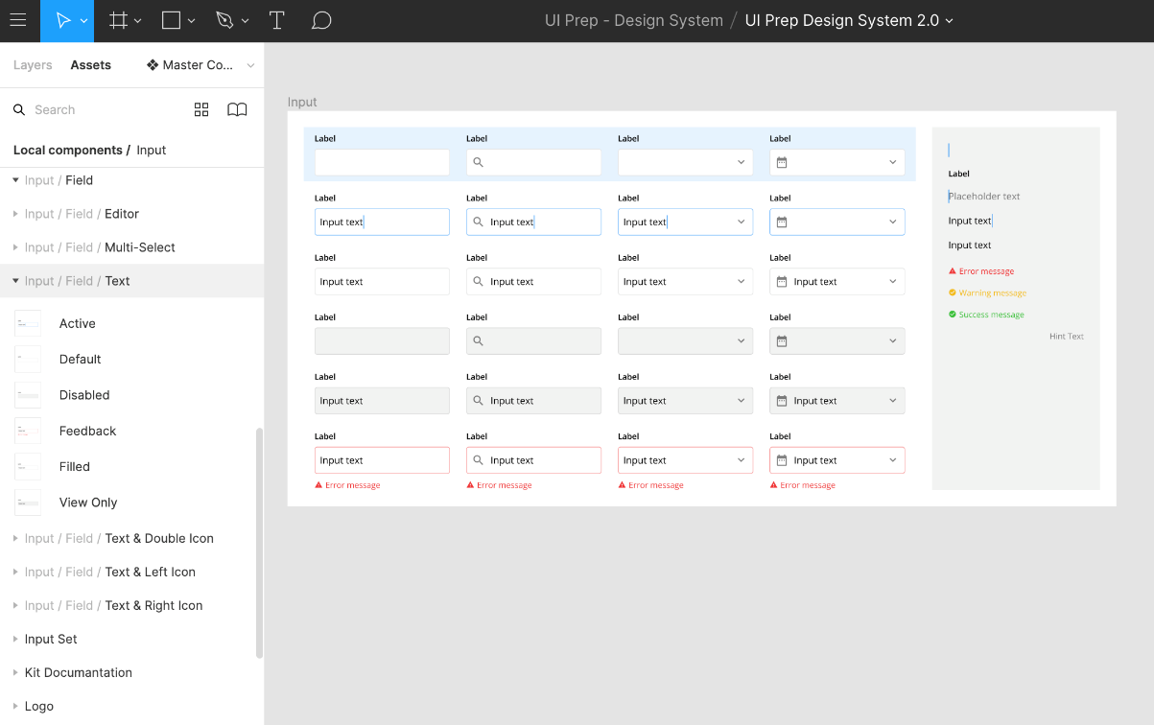

* **1. Forward slash naming to create hierarchy**
  + Example:
    - **Input/Field/Text — Active**
    - **Input/Field/Text — Default**
    - **Input/Field/Text — Disabled**
    - **Input/Field/Text — Feedback**
    - **Input/Field/Text — Filled**
    - **Input/Field/Text — View Only**
  + For access to a wider subcategory of “related components” in the instance menu you can combine the last two labels, ie. input type (text) and input status (default), by separating them with a dash instead of a slash. This is particularly useful for larger categories with many subcategories.
* Group components in frames to better visualize (ex data table, date picker, dropdown as different frames)

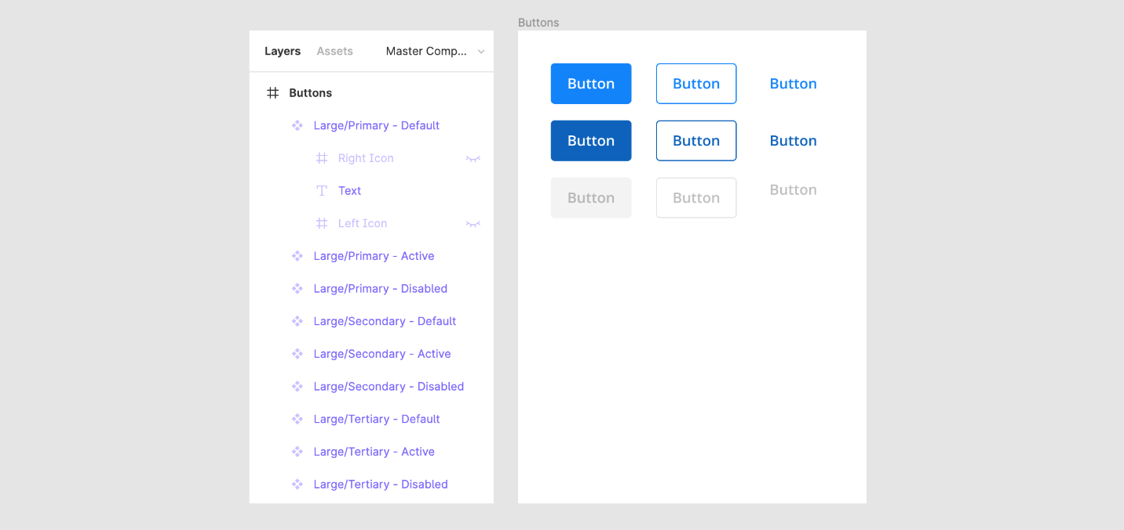

* **2. Choose easy to understand method for structing component states and variations**
  + Separate master components for each variation
    - Fast to change state of instance, change multiple instances ast the same time, can save text overrides when updating state or variation, consistent
    - Downside: clutter



* 3. **Use nested atomic components as global building blocks**
  + The best approach for this is to create a set of reusable atomic components with the sole intention of nesting atomic instances inside other related components.
    - Take textfields as an example. We can turn a textfield’s shape into an atomic component and nest it’s instances inside every other textfield component we create.
    - This means all textfields use the exact same building block (i.e., the atomic instance) and if the shape of textfields were to change, all we’d need to do is update the atomic component and all other textfield components would update too.
    - Using an atomic approach allows you to seamlessly apply globalized changes to components which makes it much easier to maintain your system.

**Working with Components**



* Set up constraints and layout grid to show responsive behavior of component as it is resized
* Preserve text overrides on instance swaps
  + To do this make sure the text layer within each component share the same name (e.g., “**Button Text**”). If you don’t do this your text overrides will not persist and you’ll need to manually update the text after you swap instances.
  + 
* Use clip content to reduce repetitive instances
  + Toggle whether or not elements extend beyond the bounds of the component are cropped or hidden
  + 
* Document components when hovering over it in the assets panel: provides context as to how it works and fits with the product
* Use instance overrides to adapt components
  + Override properties of instance without breaking link to master component
  + Can be used on text, color, effects (drop shadow, blur), advanced (size of component, swap nested instance, toggle on/off layers)
* 
* 
  + updates to master component do not revert overrides in first gif sequence above.
* Reset overrirdes to go back to original properties
* Swap components:
  + Simply right click on the instance you want to switch and go to the Swap instance item. A submenu will appear with a list of related components.
* Detach instance: want to make a new component, or unique element